**Sri Lanka Institute of Information Technology**



Practical 03 Identify User Groups

**User Experience Engineering – IT3050**

B.Sc. (Hons) in Information Technology

Group: SER026_WEEKEND

Sustainable Development Goal: Life Below Water

|  |  |
| --- | --- |
| **Student ID** | **Student Name** |
| IT20281564 | M.T Sanju |
| IT20039004 | H.C Liyanage |
| IT20047542 | W.M.K.K.B Walisundara |
| IT20206550 | K.I.K.R.D.N. Kandakkulama |

**Persona**

1. **Project Manager – IT20281564**

1. **Researcher – IT20039004**

1. **Business Analyst – IT20047542**

1. **Software Developer – IT20206550**

**Empathy Map**

**1) Project Manager – IT20281564**

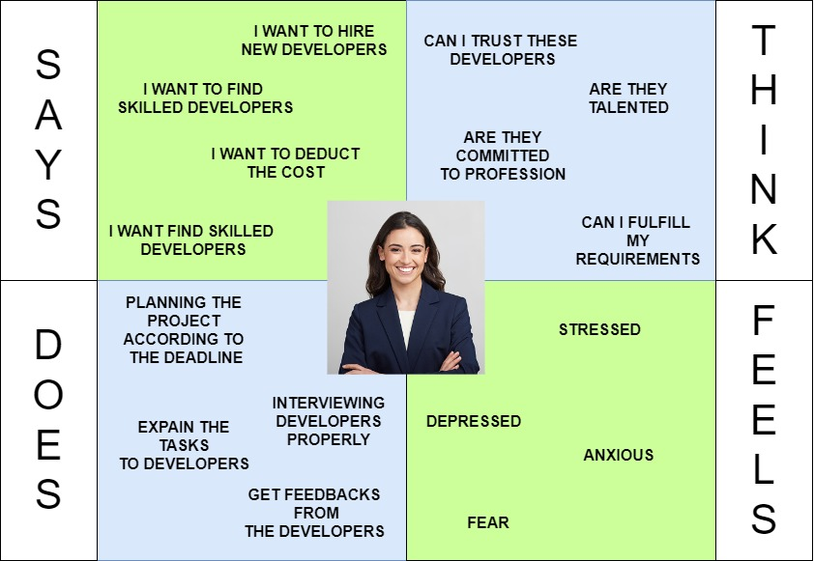

**2) Researcher– IT20039004**

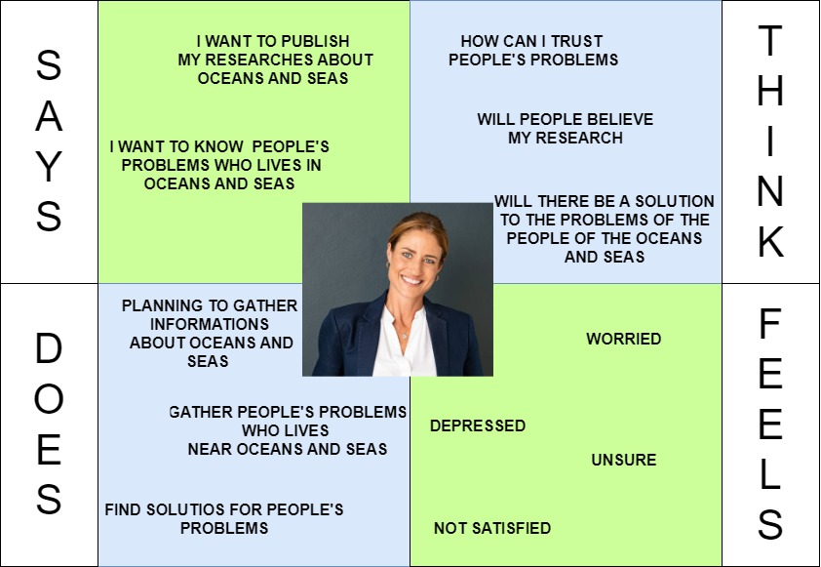

+-

**3) Business Analyst– IT20047542**

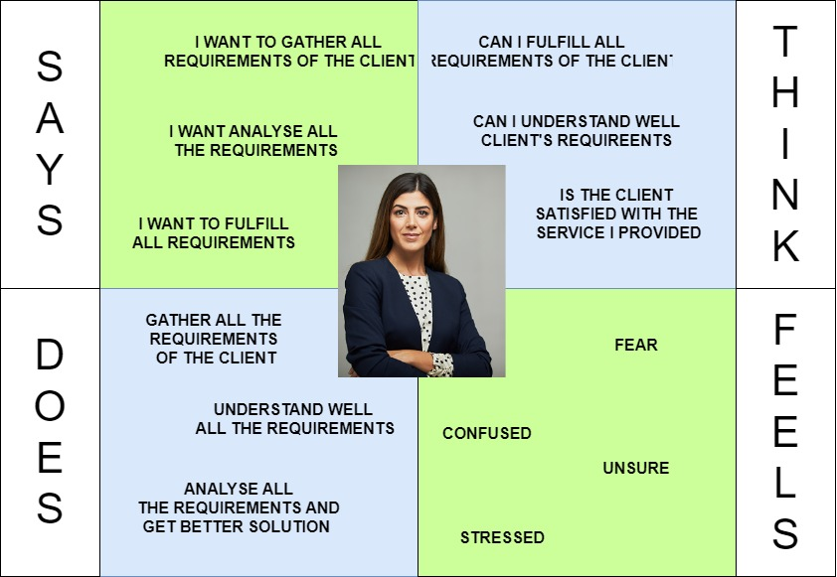

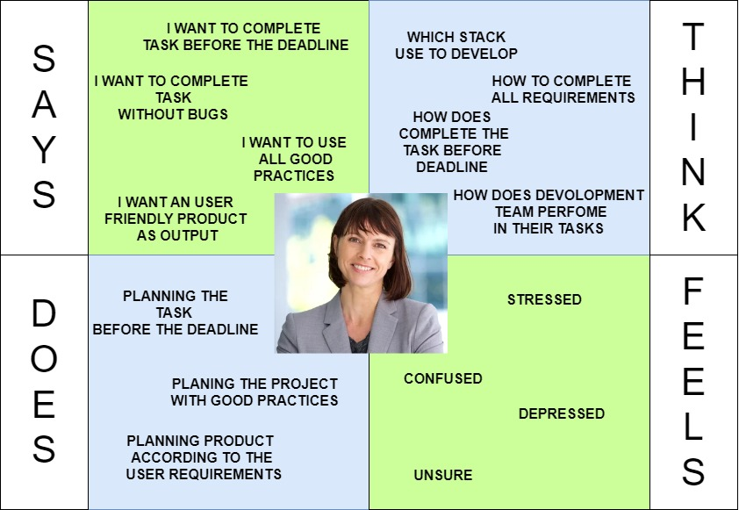**4) Software Developer - IT20206550**

IT20281564

As a Project Manager

I want to hire skilled developers

So that I can easily manage the project without dependencies

IT20039004

As an unregistered user,

I want to read a blog

So that I can get people’s opinion about fishery and their lifestyles to do my research successfully.

IT20047542

As a registered user,

I want to write a Blog

So that I can ask help from the people who are willing to help our fishery

IT20206550

As a registered user,

I want to write a Blog

So that I can give my experience of diving for the people who interested in diving

**User flow**

1. First User Flow - Manage Profile **–** IT20281564

Click on navigation button

Click on Profile

Change Details

Click on “Save”

End

Start

Splash Screen

If user is logged in already

Login/ Sign in

Home

NO

Yes

1. Second User Flow - Add Post - IT20039004

Start

Splash Screen

If user is logged in already

Login/ Sign in

Home

NO

Yes

Click On “Add New Blog”

Write the Blog

Add Images

Click On “Upload”

End

1. Third User Flow - View Blog **–** IT20047542

Start

Splash Screen

Home

Search Blog by topic

Select a Blog

Read the Blog

Click on “Back”

Home

End

1. Forth User Flow - Add Comment **–** IT20206550

Start

Splash screen

If user is logged in already

Login/ Sign in

Home

NO

Yes

End

Select a post

Click on “Add comment”

Upload a comment

Click on “Save”

**Service Blueprint**

